**PRACTICAL: 13**

**Aim:** Study different CASE tools and Testing tools (QTP, q Test, IBM Rational Functional tester,MSC(messagesequencechart),SDL(specificationanddescriptionlanguage),TTCN(testingand test control notation), TTCN-3) and prepare a summary report.

**Software required:** Various testing tools

**Knowledge Required:** Basics of Software Engineering – testing tools

**Project Name:** Community Management

# Theory:

**CASE (Computer-Aided Software Engineering)** is the use of computer-based support in the software development process. a CASE tool is a computer-based product aimed at supporting one or more software engineering activities within a software development process; a CASE environment is a collection of CASE tools and other components together with an integration approach that supports most or all of the interactions that occur among the environment components and between the users of the environment and the environment itself.

**Advantage/Disadvantage:** CASE Tools offer an excellent array of features that support the development and business community through its Automated Diagram Support feature. The various popular features that aid the development community are listed below:

* Checks for syntactic correctness
* Data dictionary support
* Checks for consistency and completeness
* Navigation to linked diagrams
* Layering
* Requirement strace ability
* Automatic report generation
* System simulation
* Performance analysis

### **CASE Tools:**

* CASE tools are set of software application programs, which are used to automate SDLC activities. CASE tools are used by software project managers, analysts and engineers to develop software system.
* There are number of CASE tools available to simplify various stages of Software DevelopmentLifeCyclesuchasAnalysistools,Designtools,Projectmanagement tools, Database Management tools, Documentation tools are to name a few.
* UseofCASEtoolsacceleratesthedevelopmentofprojecttoproducedesiredresult and helps to uncover flaws before moving ahead with next stage in software development.

### **CASE Tools Types**

### **Diagram tools**

These tools are used to represent system components, data and control flow among various software components and system structure in a graphical form. For example, Flow Chart Maker tool for creating state-of-the-art flowcharts.

### **Process Modelling Tools**

Process modeling is method to create software process model, which is used to develop the software. Process modeling tools help the managers to choose a process model or modify it as per the requirement of software product. For example, EPF Composer

### **Project Management Tools**

These tools are used for project planning, cost and effort estimation, project scheduling and resource planning. Managers have to strictly comply project execution with every mentioned step in software project management. Project management tools help in storing and sharing project information in real-time throughout the organization. For example, Creative Pro Office, Trac Project, Base camp.

### **Documentation Tools**

Documentation in a software project starts prior to the software process, goes throughout all phases of SDLC and after the completion of the project.

Documentation tools generate documents for technical users and end users. Technical users are mostly in-house professionals of the development team who refer to system manual, reference manual, training manual, installation manuals etc. The end user documents describe the functioning and how-to of the system such as user manual. For example, Doxygen, DrExplain, Adobe Robo Help for documentation.

### **Analysis Tools**

These tools help to gather requirements, automatically check for any inconsistency, inaccuracy in the diagrams, data redundancies or erroneous omissions. For example, Accept 360, Accompa, Case Complete for requirement analysis, Visible Analyst for total analysis.

### **Design Tools**

These tools help software designers to design the block structure of the software, which may further be broken down in smaller modules using refinement techniques. These tools provide detailing of each module and interconnections among modules. For example, Animated Software Design.

### **Automated Testing Tools:**

### **Selenium**

Selenium is possibly the most popular open-source test automation framework for Web applications. Being originated in the 2000s and evolved over a decade, Selenium has been an automation framework of choice for Web automation testers, especially for those who possess advanced programming and scripting skills. Selenium has become a core framework for other open-source test automation tools such as Katalon Studio, Watir, Protractor, and Robot Framework. Selenium support multiple system environments (Windows, Mac, Linux) and browsers (Chrome, Firefox, IE, and Headless browsers). Its scripts can be written in various programming languages such as Java, Groovy, Python, C#, PHP, Ruby, and Perl.

WhiletestershaveflexibilitywithSeleniumandtheycanwritecomplexandadvancedtestscripts to meet various levels of complexity, it requires advanced programming skills and effort to build automation frameworks and libraries for specific testing needs.

### **QTP**

Unified Functional Testing (UFT) software, formerly known as HP

Quick Test Professional (QTP), provides functional and regression test automation for software applications and environments. HPE Unified Functional Testing can be used for enterprise quality assurance. HPEUnifiedFunctionalTestingsupportskeywordandscriptinginterfacesandfeaturesagraphical user interface. It uses the Visual Basic Scripting Edition (VBScript) scripting language to specify a test procedure, and to manipulate the objects and controls of the application under test.

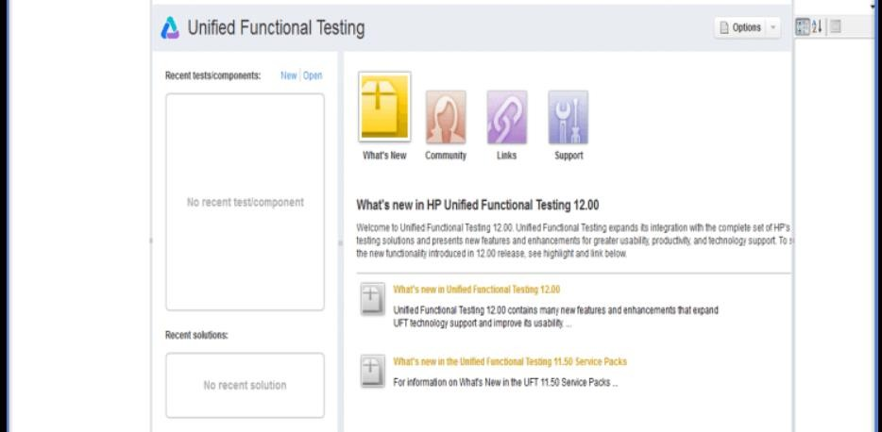

### **Q Test**

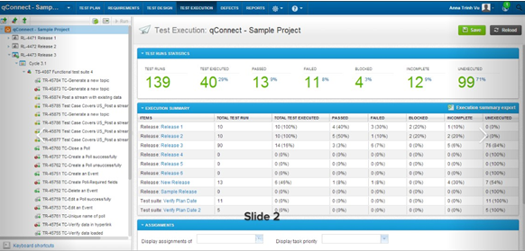

There are many great features of this test case management tool, below are some:

* + - You can import and export test cases from Excel spreadsheet or other test management tools
    - Features to re-use test cases and test suites across multiple releases
    - Easy requirement management and traceability
    - Complete control over who modifies test cases
    - Track changes to test cases and requirements
    - Robust reporting with real-time status of test cycles, test results, test progress, and team productivity.

### **IBM Rational**

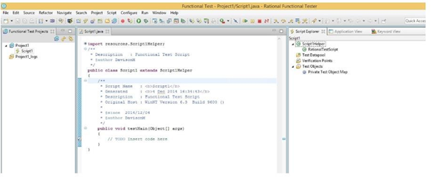

Rational Functional Tester is an object-oriented automated functional testing tool capable of performing automated functional, regression, GUI, and data-driven testing. RFT supports a wide range of applications and protocols, such as HTML, Java, .NET, Windows, Eclipse, SAP, Siebel, Flex, Silverlight, Visual Basic, Dojo, GET and PowerBuilder applications.

Rational Functional Tester includes the following features:

* Broad skills match – the IBM RFT tool has been designed for users of varying technical abilities to ensure your quality assurance team isn’t tied up with basic
* Testing, and other experts in your business can get involved with and understand the testflow using a visual story boardf ormat.
* IBM Script Assure® – advanced IBM technology learns user interface characteristics and applies them to new software versions saving time spent creating new tests cripts.
* Automated scripts – Rational Functional Tester enables your development teams to create keyword associated scripts which allows for easy re-use, improving efficiency.
* Eclipse Java Developer Toolkit editor – makes it easy for your team to code test scripts in Java with Eclipse. It automates code completion and offers advanced debugging options.

### **TTCN-3**

The testing and test control notation (TTCN-3) is a new test specification and test implementation language that supports all kinds of black-box testing of distributed systems.

TTCN-3 is built from a textual core language that provides interfaces to different data description languages and the possibility of different presentation formats. This makes TTCN-3 quite universal and application independent.

